EXPERIMENT-1
UniSphere – Student Enterprise Resource Planning System
Requirements • Agile Process • Technology • Implementation • Testing
Student Name: AKSHATH
Roll Number: 2420030512
Course / Subject: Software Engineering
Academic Year: 2026–2027

1. Project Overview
UniSphere is a student-centric University Enterprise Resource Planning (ERP) system designed to bring essential academic services into one portal. It covers student authentication, dashboard information, academic registration, attendance, courses, results, fees, timetable, examinations, library access, profile management and support.
The functional scope was informed by publicly accessible KL University ERP material. The reference portal exposes student login and modules including Academic Registration, Attendance Register, Courses, End Exam Result, Fee Payments, Hallticket, My CGPA, Profile, Timetables and other student services. UniSphere is an original case-study design with its own name, interface, sample data and screenshots. citeturn0view0turn0search15

1.1 Login and Access
Students authenticate using a university ID and password. Role-based access is proposed for Student, Faculty and Administrator accounts.
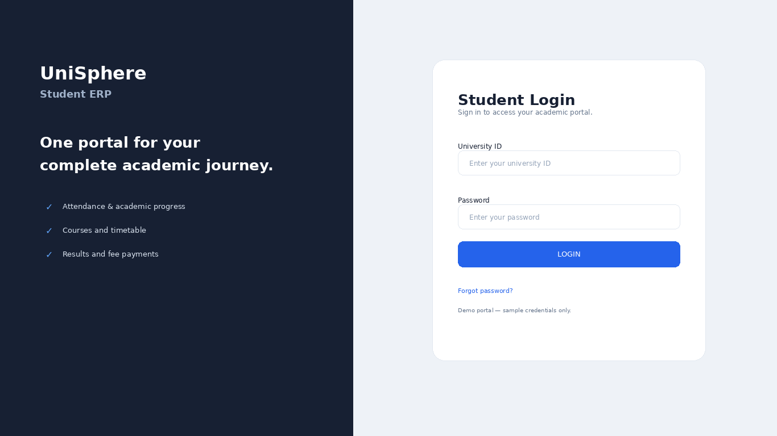
Figure 1. UniSphere Student ERP login screen – original prototype.

2. Problem Statement and Objectives
University students interact with many services throughout a semester. If attendance, registration, results, fees and timetable information are fragmented, students spend more time navigating systems and can miss important academic actions. UniSphere addresses this problem through a centralized student portal.

2.1 Objectives
- Centralize academic information in one portal.
- Allow subject-wise attendance monitoring.
- Support semester course and section registration.
- Provide results, grades, SGPA and CGPA.
- Provide fee dues, payment history and receipts.
- Provide weekly timetable and examination information.
- Provide profile and student-support services.

2.2 Scope
In Scope | Out of Scope
Student dashboard | University payroll
Academic registration | Staff HR management
Attendance | Complex hostel administration
Results and CGPA | Full transport fleet management
Fees and receipts | External banking core systems
Timetable and examinations | National education databases

2.3 Student Dashboard
The dashboard summarizes high-value information such as attendance, CGPA, earned credits, next class and upcoming academic events. The reference ERP documentation similarly describes a student portal with a home dashboard and academic service navigation. citeturn0search15
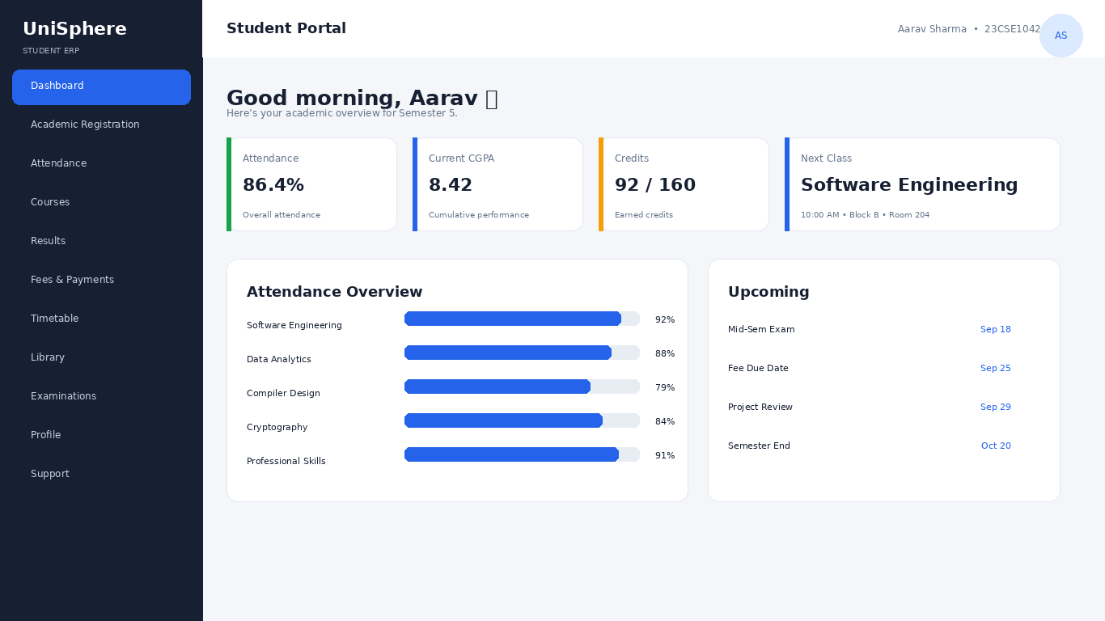
Figure 2. UniSphere Student Dashboard prototype.

3. Stakeholders and User Personas
Stakeholder | Role / Need
Student | Access academic information, register courses, monitor attendance and fees.
Faculty | Record attendance and support students.
Academic Administrator | Manage curriculum, registration and student records.
Examination Cell | Publish results and examination schedules.
Finance Office | Manage fee structures, dues, payments and receipts.
System Administrator | Maintain users, permissions, security and infrastructure.

3.1 Primary Persona
Student – an undergraduate who needs one place to check attendance, register subjects, see results, monitor fees and follow the weekly timetable.

4. User Stories
ID | Actor | User Story | Priority
US-01 | Student | As a student, I want to log in securely so that I can access my academic information. | High
US-02 | Student | As a student, I want to view my dashboard so that I can see important information quickly. | High
US-03 | Student | As a student, I want to check subject-wise attendance so that I can monitor eligibility. | High
US-04 | Student | As a student, I want to select courses and sections so that I can complete registration. | High
US-05 | Student | As a student, I want to view grades and CGPA so that I can track performance. | High
US-06 | Student | As a student, I want to see fee dues and receipts so that I can manage payments. | High
US-07 | Student | As a student, I want to view my weekly timetable so that I can plan classes. | Medium
US-08 | Faculty | As a faculty member, I want to record attendance so that student records remain current. | High
US-09 | Admin | As an administrator, I want to manage courses and students so that ERP data stays accurate. | High

4.1 Course Registration Acceptance Criteria
- Student must be authenticated.
- Only eligible courses are displayed.
- Student can select a valid section.
- Timetable conflicts are flagged.
- Registration can be saved and submitted.
- Successful submission produces confirmation.

4.2 Registration Screen
The reference ERP documentation describes course registration in which students select courses and sections and can view timetable information before saving/submitting. UniSphere applies the same business concept with an independently designed UI. citeturn0search12turn0search14
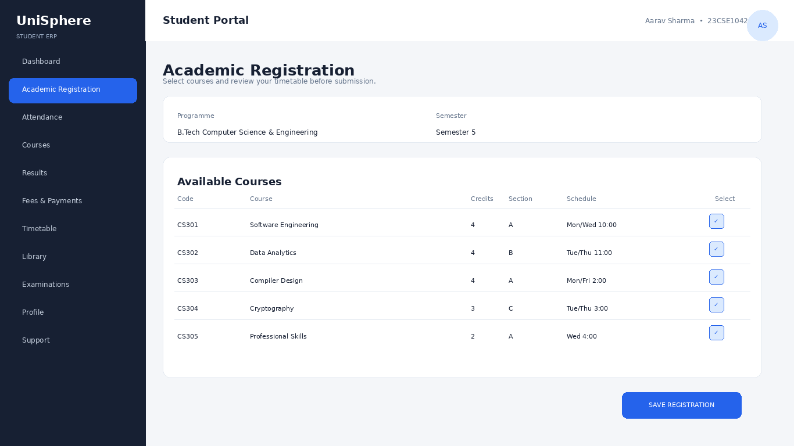
Figure 3. UniSphere Academic Registration prototype.

5. Functional Requirements
- The system shall authenticate students using university credentials.
- The system shall display a personalized dashboard.
- The system shall display attendance by course and semester.
- The system shall allow eligible students to select courses and sections.
- The system shall display current and historical results.
- The system shall display SGPA and CGPA values.
- The system shall display fee dues and payment history.
- The system shall display weekly class timetable.
- The system shall provide examination-related information.
- The system shall allow students to view permitted profile information.

5.1 Attendance Module
Attendance provides subject-level visibility including classes held, present, absent, percentage and status.
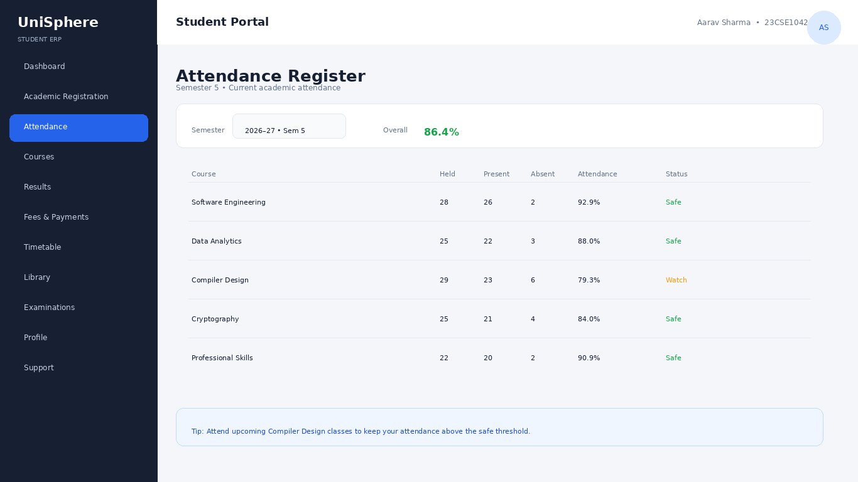
Figure 4. UniSphere Attendance Register prototype.

5.2 Results Module
The results module presents course grades, grade points, credits and pass status, with SGPA and cumulative CGPA summary cards. Publicly available ERP examples also show semester result tables and cumulative CGPA information. citeturn0search1turn0search3
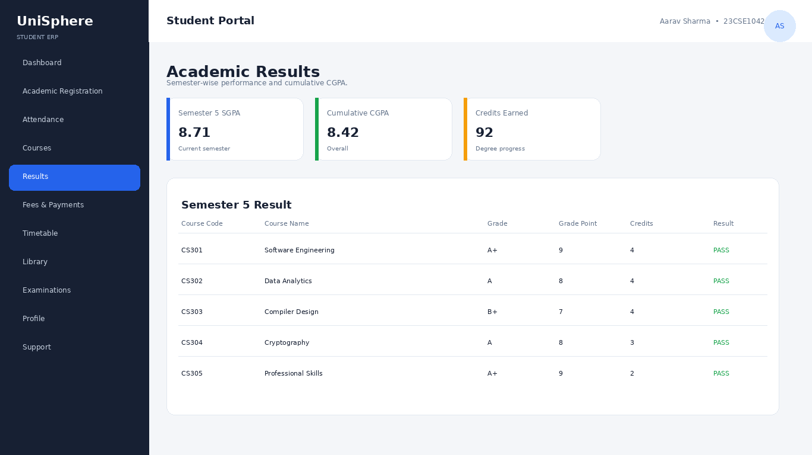
Figure 5. UniSphere Academic Results prototype.

6. Non-Functional Requirements
Attribute | Requirement / Target
Usability | Common tasks reachable within 2–3 navigation steps.
Performance | Normal pages target ≤2 seconds under typical load.
Security | Authentication, authorization, secure sessions, validation and HTTPS.
Reliability | Transactional updates for registration, payments and academic records.
Availability | Target 99.5%+ production availability.
Scalability | Indexed queries and scalable web layer.
Maintainability | Modular services, tests and documentation.
Accessibility | Readable contrast, keyboard navigation and labels.

7. Software Development Process Model

7.1 Selected Model – Agile Scrum
Agile Scrum is suitable because ERP requirements can evolve after feedback from students, faculty and administrative departments. The system can be delivered module-by-module and reviewed after each sprint.
Sprint | Deliverables
Sprint 0 | Requirements, personas, backlog, architecture and wireframes.
Sprint 1 | Login, roles and dashboard.
Sprint 2 | Attendance and courses.
Sprint 3 | Registration and timetable.
Sprint 4 | Results, CGPA and examinations.
Sprint 5 | Fees, receipts and notifications.
Sprint 6 | Testing, security, performance and deployment.

7.2 Scrum Activities
- Product Backlog
- Sprint Planning
- Daily Scrum
- Sprint Review
- Retrospective
- Definition of Done

8. Programming Language and Technology Selection
Technology | Purpose | Justification
Python | Backend programming | Readable, productive and mature ecosystem.
Django | Web framework | ORM, authentication, admin, routing and security features.
PostgreSQL | Database | Strong transactional support.
HTML5/CSS3 | Web UI | Standard browser technologies.
JavaScript | Interaction | Dynamic forms and dashboards.
REST API | Integration | Supports mobile and other university systems.
Git + CI/CD | Development | Version control and repeatable releases.

8.1 Proposed Architecture
The architecture separates the interface, business logic, data and external services. This improves maintainability and enables future mobile clients to reuse backend APIs.
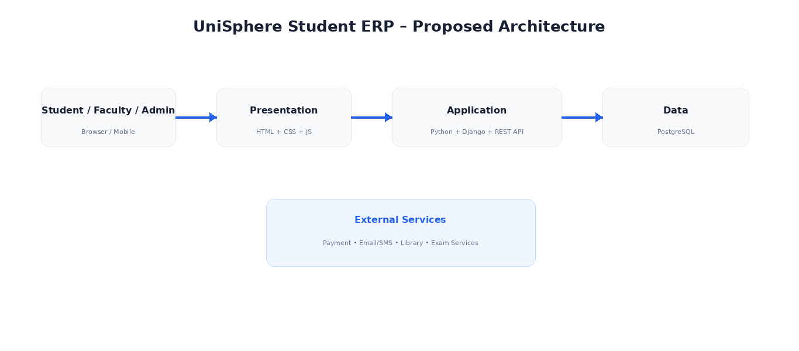
Figure 6. Proposed UniSphere layered architecture.

8.2 Core Database Entities
Entity | Key Fields
Student | student_id, name, programme, semester, email
Course | course_id, code, name, credits, department
Enrollment | student_id, course_id, section, semester, status
Attendance | student_id, course_id, date, status
Result | student_id, course_id, grade, grade_point, credits
Fee | student_id, fee_type, amount, due_date, status
Payment | payment_id, student_id, amount, date, receipt_no
Timetable | course_id, day, start_time, room, faculty

9. Implementation Strategy
- Create the Git repository and Django project.
- Configure PostgreSQL and environment variables.
- Create Student, Faculty, Course, Enrollment, Attendance, Result, Fee and Payment models.
- Implement authentication and role-based access.
- Build dashboard APIs and UI.
- Implement attendance and registration modules.
- Implement results, CGPA and examination modules.
- Implement fees, receipts and sandbox payment integration.
- Implement timetable, profile and support modules.
- Add logging, validation, automated tests and deployment configuration.

9.1 Fee & Payment Module
The fee module displays assessed fees, paid amount, outstanding balance and transaction history. A production implementation should use a compliant payment provider rather than storing raw card information.
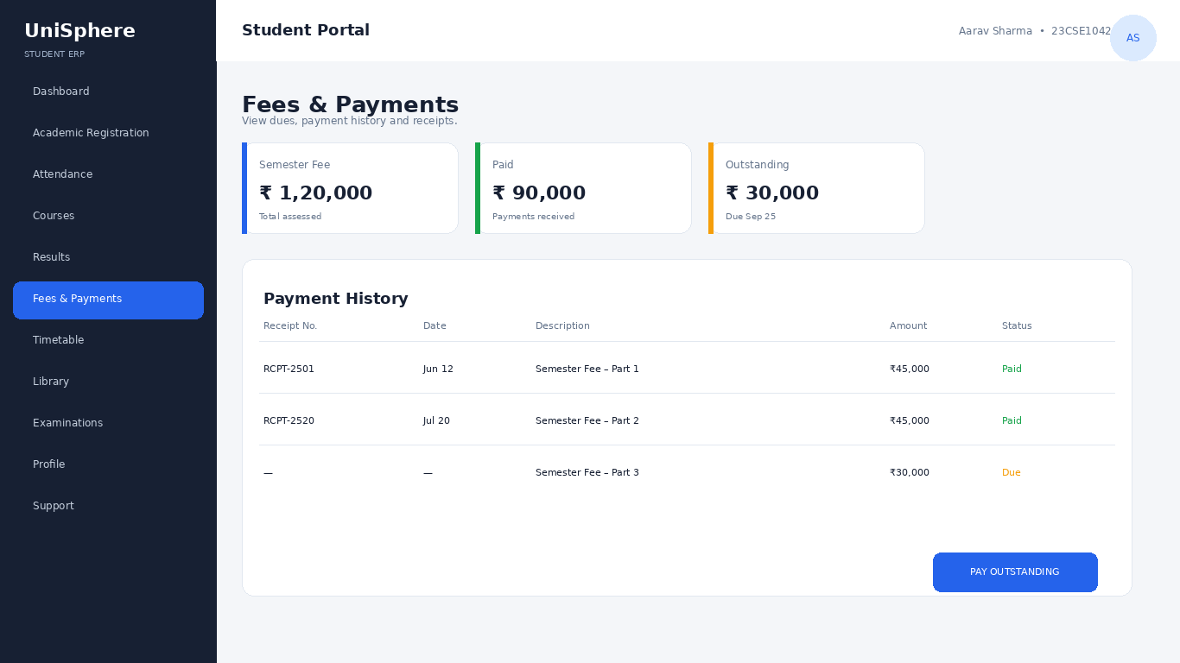
Figure 7. UniSphere Fees & Payments prototype.

9.2 Timetable Module
The timetable provides a weekly view of scheduled classes. Registration can use the timetable to identify conflicts before submission.
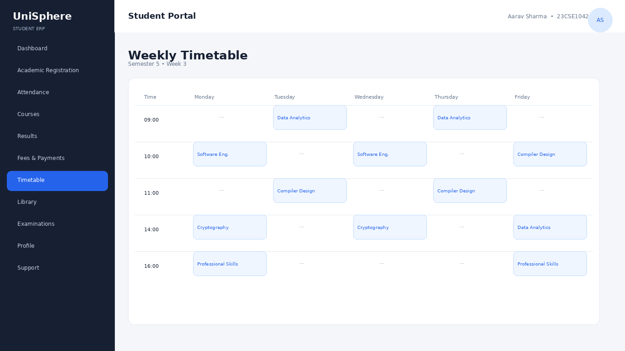
Figure 8. UniSphere Weekly Timetable prototype.

10. Profile and Student Services
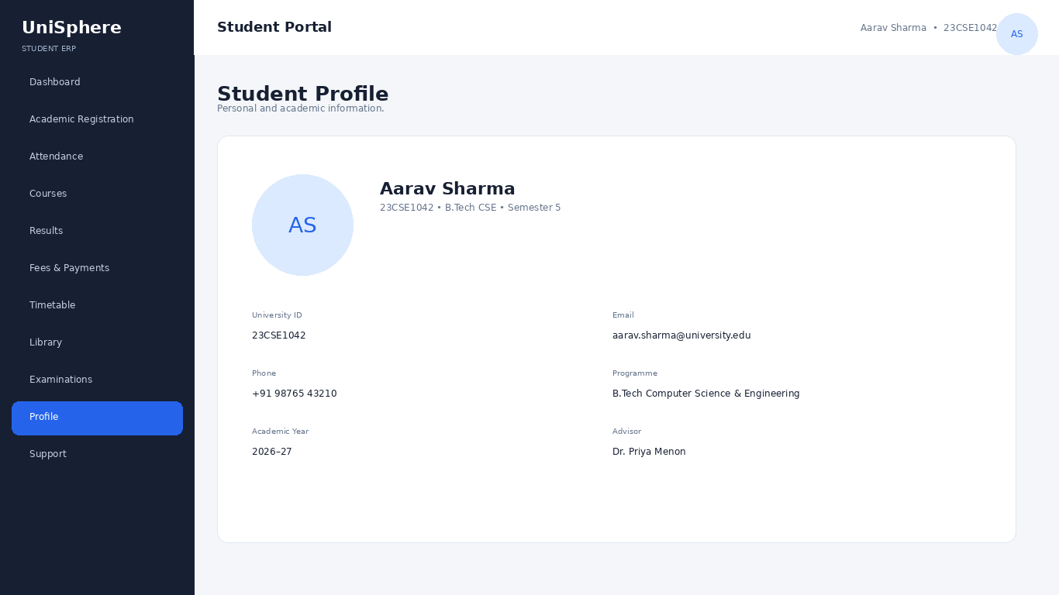
Figure 9. UniSphere Student Profile prototype.
Module | Main Functions
Dashboard | Attendance, CGPA, credits, alerts and events
Academic Registration | Course/section selection and submission
Attendance | Subject-wise attendance and history
Courses | Course catalogue and enrolled courses
Results | Grades, SGPA, CGPA and history
Fees & Payments | Dues, receipts and payment history
Timetable | Weekly schedule and rooms
Library | Books, loans, fines and availability
Examinations | Exam schedule, hall ticket and results
Profile | Student information and account settings
Support | Tickets and issue tracking

11. Testing and Evaluation Strategy

11.1 Testing Levels
- Unit Testing
- Integration Testing
- System Testing
- Usability Testing
- Security Testing
- Performance Testing

11.2 Sample Test Cases
ID | Test | Expected Result | Status
TC-01 | Valid login | Dashboard opens | Pass
TC-02 | Invalid login | Safe error displayed | Pass
TC-03 | Open attendance | Correct semester attendance shown | Pass
TC-04 | Select valid course | Course added | Pass
TC-05 | Timetable conflict | Conflict warning | Pass
TC-06 | Open results | Grades and credits shown | Pass
TC-07 | View fees | Correct balance shown | Pass
TC-08 | Unauthorized admin URL | Access denied | Pass
TC-09 | Responsive dashboard | Usable at smaller width | Pass

11.3 Evaluation Metrics
Metric | Measurement | Target
Functional correctness | Test pass rate | ≥95%
Usability | Task completion | ≥90%
Performance | Page/API response | ≤2 sec
Security | Critical vulnerabilities | 0
Availability | Production uptime | ≥99.5%
User satisfaction | Post-test survey | ≥4/5

12. Risks and Mitigation
Risk | Impact | Mitigation
Incorrect academic data | High | Validation, audit logs and controlled updates.
Unauthorized access | High | RBAC and security tests.
Payment issues | High | Compliant gateway and reconciliation.
Requirement changes | Medium | Agile backlog and sprint reviews.
Registration peak load | High | Load testing, indexes, caching and capacity planning.
Downtime | High | Monitoring, backups and recovery.
Privacy exposure | High | Least privilege, encryption and secure data handling.

13. Future Enhancements
- Mobile application using the same REST API.
- AI-based academic progress insights.
- Attendance and academic-risk alerts.
- Integrated LMS and assignment notifications.
- Digital campus ID services.
- Parent/guardian read-only portal where institution policy permits.
- Faculty and administrator analytics.
- Single sign-on across university services.

14. Conclusion
UniSphere demonstrates how a student ERP can be analyzed and designed using software engineering principles. Agile Scrum supports incremental delivery, Python/Django provides a practical application platform, and PostgreSQL supports reliable transactional data. The prototype screens demonstrate the complete student journey across login, dashboard, attendance, registration, results, fees, timetable and profile.

15. Reference Basis
The case study used publicly accessible KL University ERP pages and university ERP guidance as functional references, particularly for student login, dashboard navigation, academic registration, attendance, results, fees and student services. The UniSphere branding, interface, sample data and screenshots are independently created mockups for this assignment and are not screenshots of KL University’s portal. citeturn0view0turn0search12turn0search15
Replace the student details on the cover page before LMS submission.

